COVER SHEET FOR THE CHARITY FAMILY
SCHOLARSHIP APPLICATION - DEADLINE FOR SUBMISSION – JUNE 1, 2019

Click here to enter text.
NAME (INSERT ABOVE)

INSTRUCTIONS:
Note: Be sure to save this as a Word doc. You may also scan and save this document as a .pdf (because of the letters of recommendation that need to be added) and submit it, or you can print it and mail it in.
PLEASE CLICK ON THE CENTER ICON AND UPLOAD A PICTURE OF YOURSELF SO WE WILL KNOW WHO YOU ARE!
AREA YOU PLAN TO STUDY:
Click here to enter text.

The Charity Family Scholarship Committee commends you on taking this step in advancing your education. We will do everything in our power to help you with whatever we can to help curb some of your expenses! While we rely solely on the donations from family and friends, we cannot guarantee any set amount that you may be awarded. Our aim is to give generously to make a small difference in your educational endeavors.

We wish you the very best and we are here to help you succeed!

The Charity Family Scholarship Committee
COMMITTEE MEMBERS:
Fcholt55@gmail.com – Faith Nelson
glowormh@aol.com – Gloria Harver
brebrandon81@yahoo.com – Sabrena Brandon
donaldcharity@gmail.com – Donald Charity
Delta76@Comcast.net – Linda Washington
Dionna.dunbar@gmail.com – Dionna Daniel
Rules for Applying for the Charity Family Scholarship:

1. You may only apply for a scholarship ONCE! This applies to all applicants – Repeat applications will not be considered for a scholarship! Siblings may apply also, even if they are enrolling for the same year.
2. Your school must be a 4-year accredited college or university; or
3. 2-year community college (please provide proof of acceptance and declared program of study).
4. Trade schools will be accepted as long as it is a 1-2 year certificate program (please include proof of acceptance).
5. If any applications are received after June 1st, it will be declined. Please be reminded that you may apply for the next award year in 2021. Our awards are given every two years.
6. START EARLY! You have plenty of time to get this in. If you start filling this out early March/April 2019, you should already know what your major will be and you will be able to do your essays and get your letters of recommendation in to the Committee. Please don’t wait until the last minute!
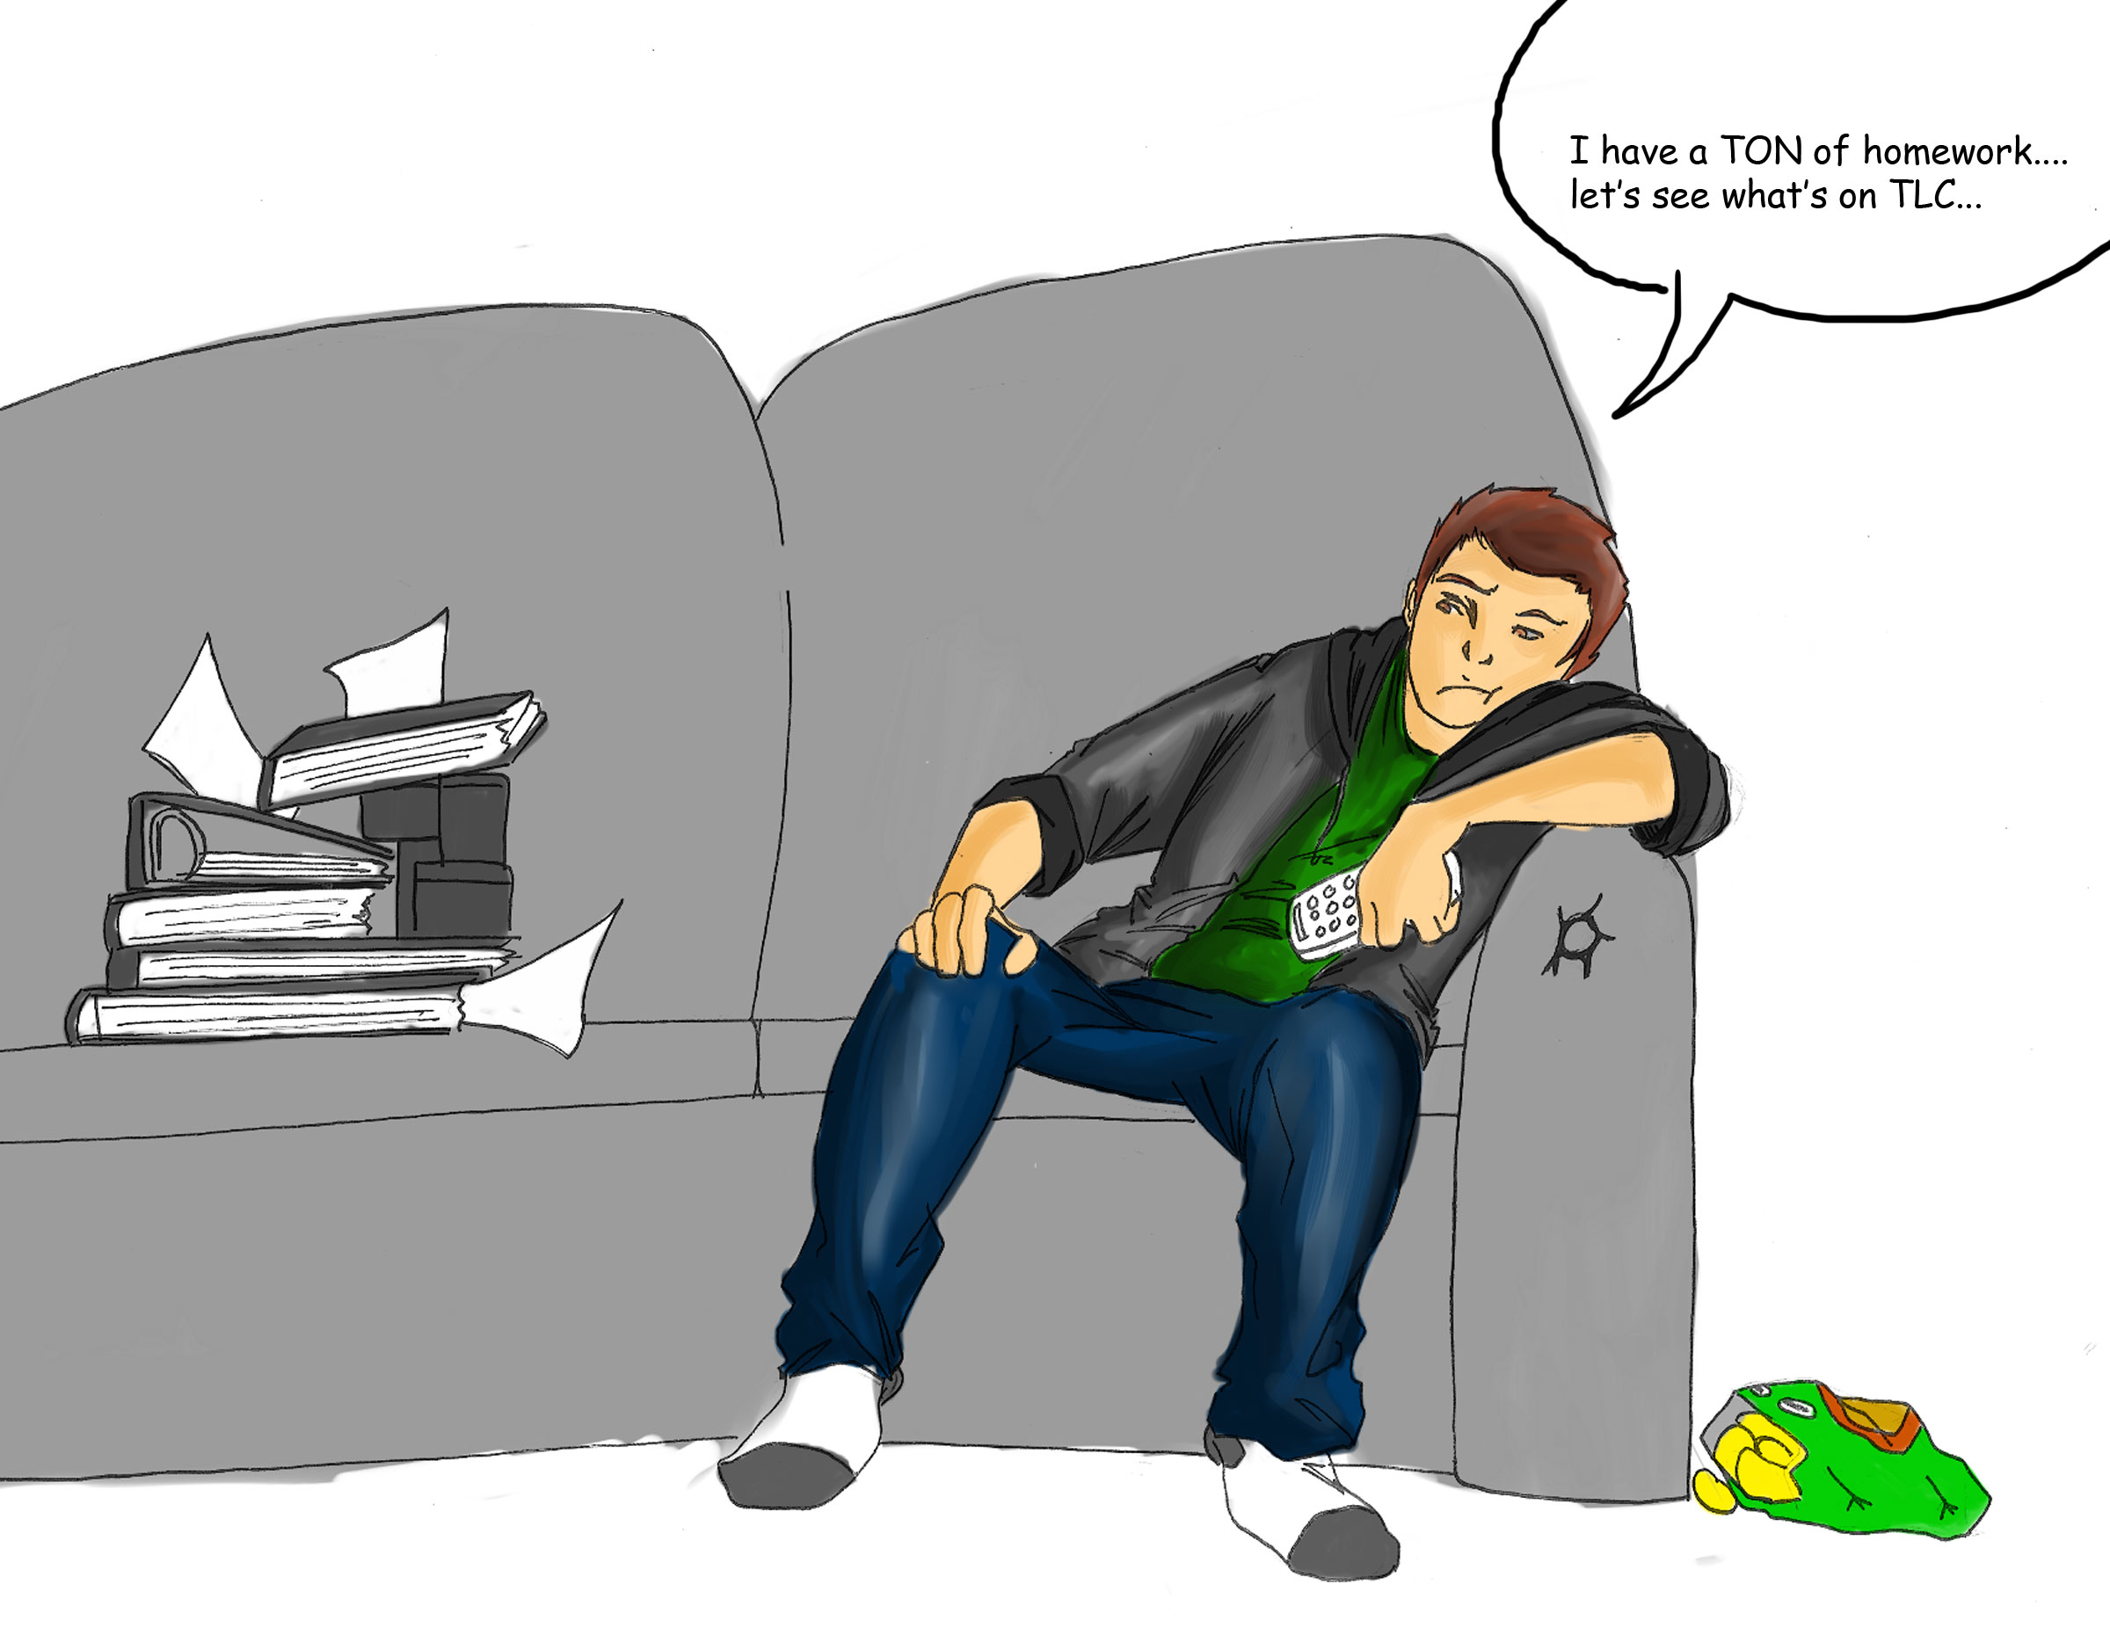

THE CHARITY FAMILY
SCHOLARSHIP APPLICATION
DEADLINE FOR SUBMISSION – JUNE 1, 2019
APPLICATION INFORMATION
- NAME: Click here to enter text.
- ADDRESS: Click here to enter text.
- PHONE NO.: Click here to enter text.
- E-MAIL: Click here to enter text.
- BIRTH DATE: Click here to enter text.
- PARENT(S) OR GUARDIAN(S) NAME(S): Click here to enter text.
- PARENT/GUARDIAN(S) ADDRESS (IF DIFFERENT FROM YOURS):
Click here to enter text.

- PHONE NO.: Click here to enter text.

- LIST THOSE WHO DEPEND ON PARENTS/GUARDIAN(S) FOR SUPPORT:
NAME AGE RELATIONSHIP
Click here to enter text. ___ Click here to enter text.
Click here to enter text. ___ Click here to enter text.
Click here to enter text. ___ Click here to enter text.
Click here to enter text. ___ Click here to enter text.
(add more if needed)

- NAME OF HIGH SCHOOL: Click here to enter text.

- DATE OF GRADUATION: Click here to enter text.

- NAME AND LOCATION OF COLLEGE TO WHICH YOU HAVE BEEN ACCEPTED TO OR ARE NOW ATTENDING:
Click here to enter text.
- WHAT YEAR OF COLLEGE ARE YOU IN? (PLEASE CHECK ONE):
FRESHMAN ☐ SOPHOMORE ☐
JUNIOR ☐ SENIOR ☐
ESSAY
Please tell us a little something about yourself first: (Hobbies, your passion, what you value the most, family tidbits, something funny about yourself, etc.):
Click here to enter text.

(Please say something about yourself that very few people know that you don’t mind sharing):
Click here to enter text.

EDUCATIONAL GOALS: Not less than 150 and not more than 200 words. Use as much space as you need.
Click here to enter text.

Prepare a brief personal profile that includes 4 or more of the following. Please use as much space as you need.

EDUCATIONAL ACHIEVEMENTS:
Click here to enter text.

SCHOOL ACTIVITIES:
Click here to enter text.

COMMUNITY INVOLVEMENT:
Click here to enter text.

AWARDS/HONORS:
Click here to enter text.

EMPLOYMENT:
Click here to enter text.

SKILLS:
Click here to enter text.

LETTER OF RECOMMENDATION - From one or more of the following. Please scan and attach them with your application or mail them in. The more recommendations, the better!
SCHOOL COUNSELOR & TEL. NO.: Click here to enter text.

COMMUNITY GROUP & TEL NO.: Click here to enter text.

FRIEND OR NEIGHBOR & TEL NO.: Click here to enter text.

If you are a recipient of a scholarship from the Charity Family, would you be willing to donate back to the Scholarship Fund to help someone else curb their educational expenses? Yes ☐ No ☐

If you would like to speak at our next reunion as to how the family has helped you with a scholarship, please indicate here. Yes ☐ No ☐
If you are interested in volunteering some time to help the Scholarship Committee, please indicate here: Yes ☐ No ☐

Date Submitted: Click here to enter a date.

Thank you so much for your submission! The Scholarship Committee will be in touch with you after we have had a chance to review all applications!

You may E-mail your completed application to:
Fcholt55@gmail.com
- OR -
If you prefer to mail it, mail to:
Charity Family Scholarship Committee
c/o Faith Charity Nelson, Committee Chair
318 Chipper Way, Henrico, VA 23075

(Note: E-mail is the best way to ensure your application reaches me because it’s an automatic date/time stamp. If you mail it, it must be postmarked by June 1, 2019)

